Terraform Task-2
Create 2 EC2 instances on 2 different regions and install nginx using terraform script

Install Terraform file.
sudo yum install -y unzip wget
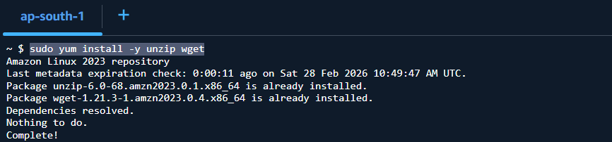

wget https://releases.hashicorp.com/terraform/1.8.5/terraform_1.8.5_linux_amd64.zip
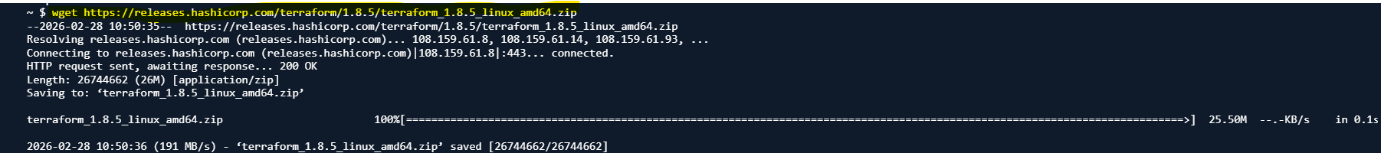
unzip terraform_1.8.5_linux_amd64.zip
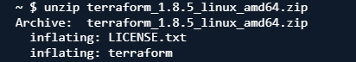
sudo mv terraform /usr/local/bin/
terraform version
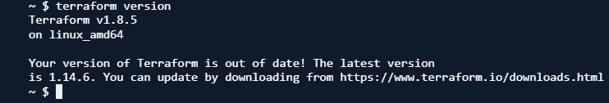

Main.tf

provider "aws" {
region = "eu-central-1"
}
provider "aws" {
alias = "us"
region = "eu-west-3"
}
resource "aws_instance" "europe-frankfort" {
ami = "ami-0df0e4e99bf8601b4"
instance_type = "t2.micro"
tags = {
Name = "europe-frankfort"
}
provisioner "remote-exec"{
connection {
type = "ssh"
user = "ec2-user"
private_key =file("~/.ssh/id_rsa")
host =self-public_ip
}
inline = [
"sudo yum update -y",
"sudo yum install -y nginx",
"sudo systemctl start nginx",
"sudo systemctl enable nginx"
]
}
}
resource "aws_instance" "europe-paris" {
provider = aws.us
ami = "ami-0c5c1b3399d21cdc6"
instance_type = "t2.micro"
tags = {
Name = "europe-paris"
}
provisioner "remote-exec"{
connection {
type = "ssh"
user = "ec2-user"
private_key =file("~/.ssh/id_rsa")
host =self-public_ip
}
inline = [
"sudo yum update -y",
"sudo yum install -y nginx",
"sudo systemctl start nginx",
"sudo systemctl enable nginx"
]
}
}

Create the rsa private key using the command below.
ssh-keygen -t rsa -b 4096 -f ~/.ssh/id_rsa

Execute the
-terraform init
- terraform validate
- terraform plan
- terraform apply

Ec2 instance will be created in the 2 different regions and install nginx using terraform script

europe-frankfort
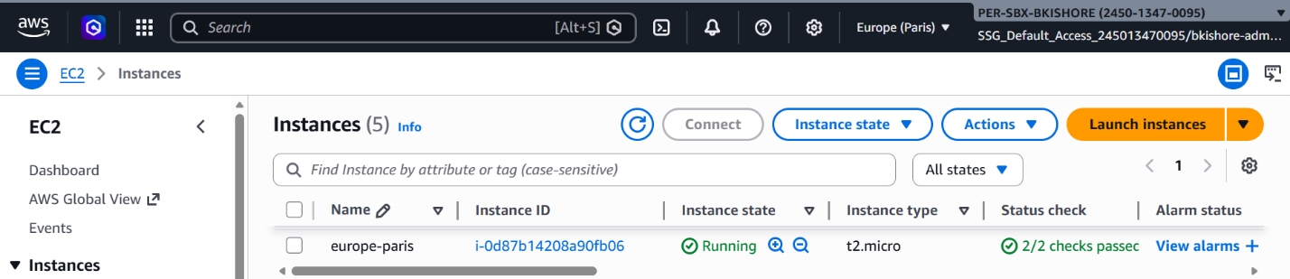
europe-paris
